

**\* Please allow 2 weeks for completion \***

2740 South Ave W Suite 101

Missoula MT 59804-5114

406-728-6101

Fax # 406-721-3278

www.sandyj@orthopaedic.com

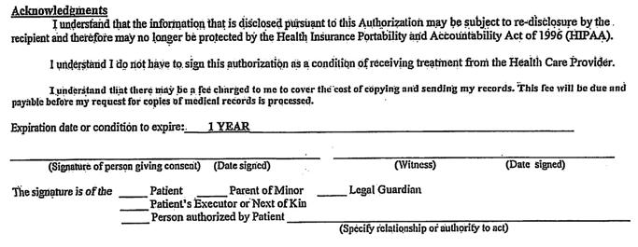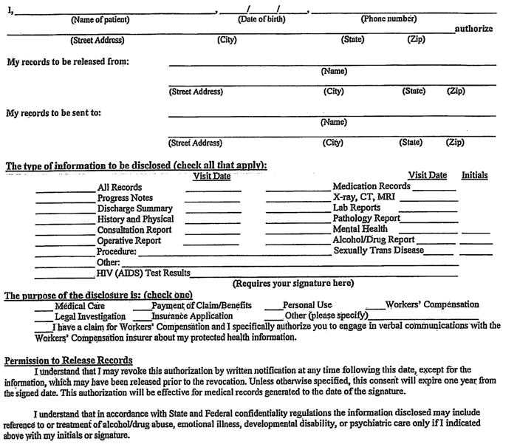**Authorization for Release of Medical Information**